

IBM DATA ANALYTICS ASSIGNMENT - 2

Name: VINAYAK SHUKLA

Mail Id:vinayak.21bce7920@vitapstudent.ac.in

Lecture Name: Indra Sir

**Now the data set that we have used in the HRDataset_v14.csv this is the name**

**modification for the data set is deleting the Emp id this is the unimportant row and after that create the Dashboard, Report, Story**

**This is the real shown in the Excel sheet**

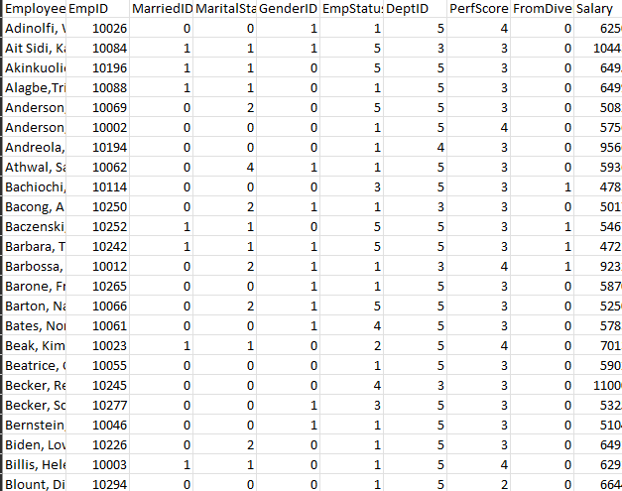

**Modified**

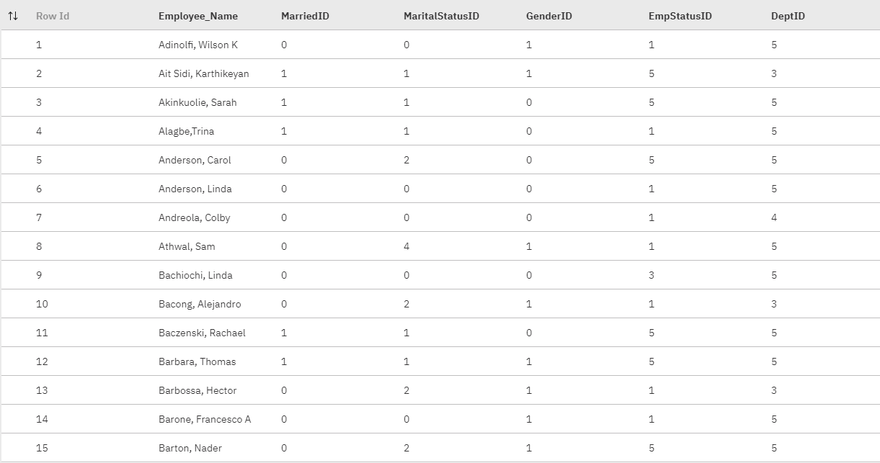

**Now the Dashboard pics**

**1. This Dashboard contain all boxed visualizations**

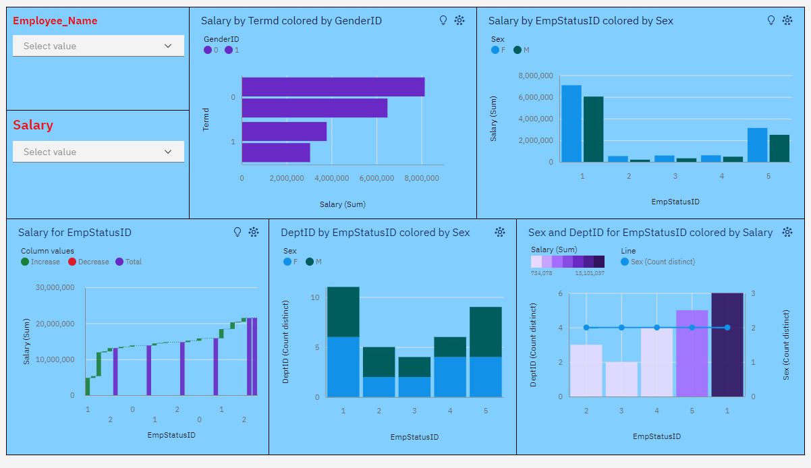

**2. This Dashboard contain all Circular visualizations**

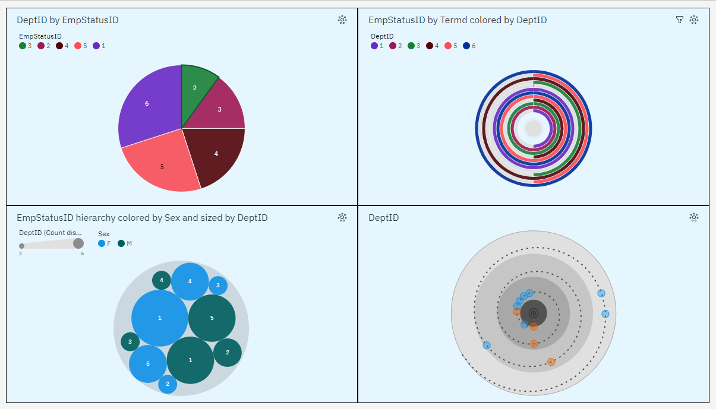

**3. This Dashboard Contain all the no shaped visualizations**

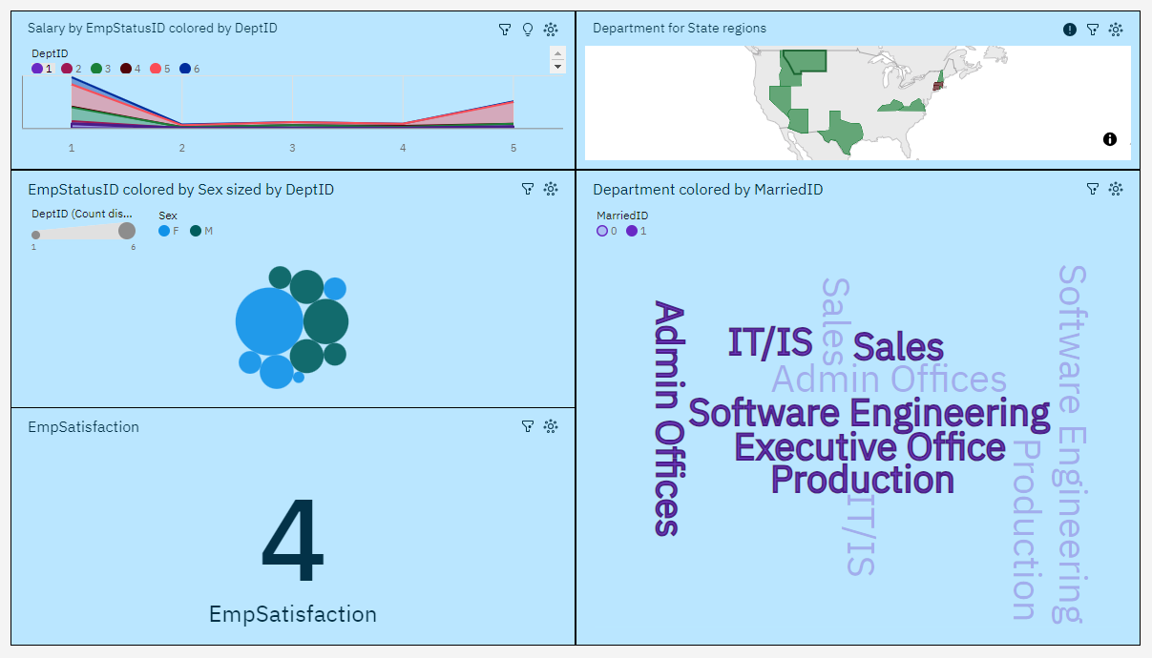

**Now See the Reports for the Data module**

**1. This Report contain all Circular visualizations**

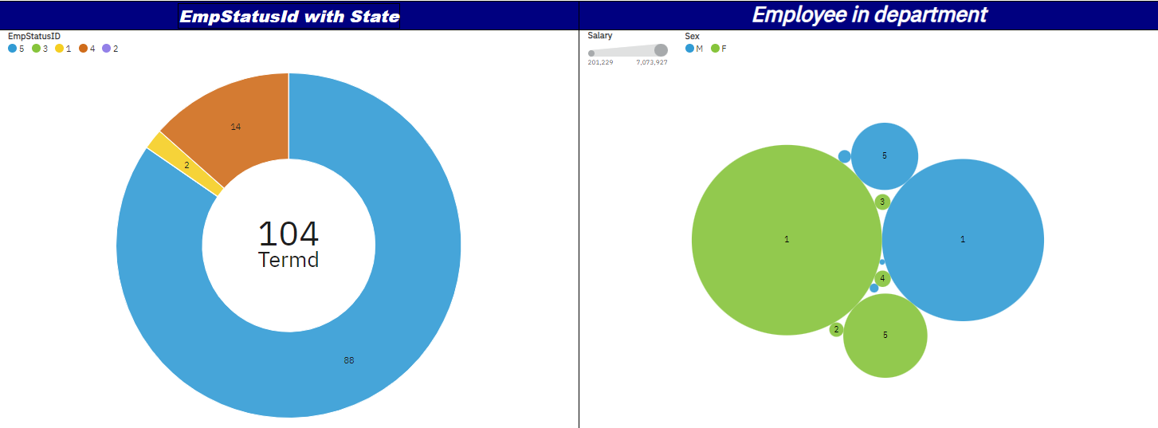

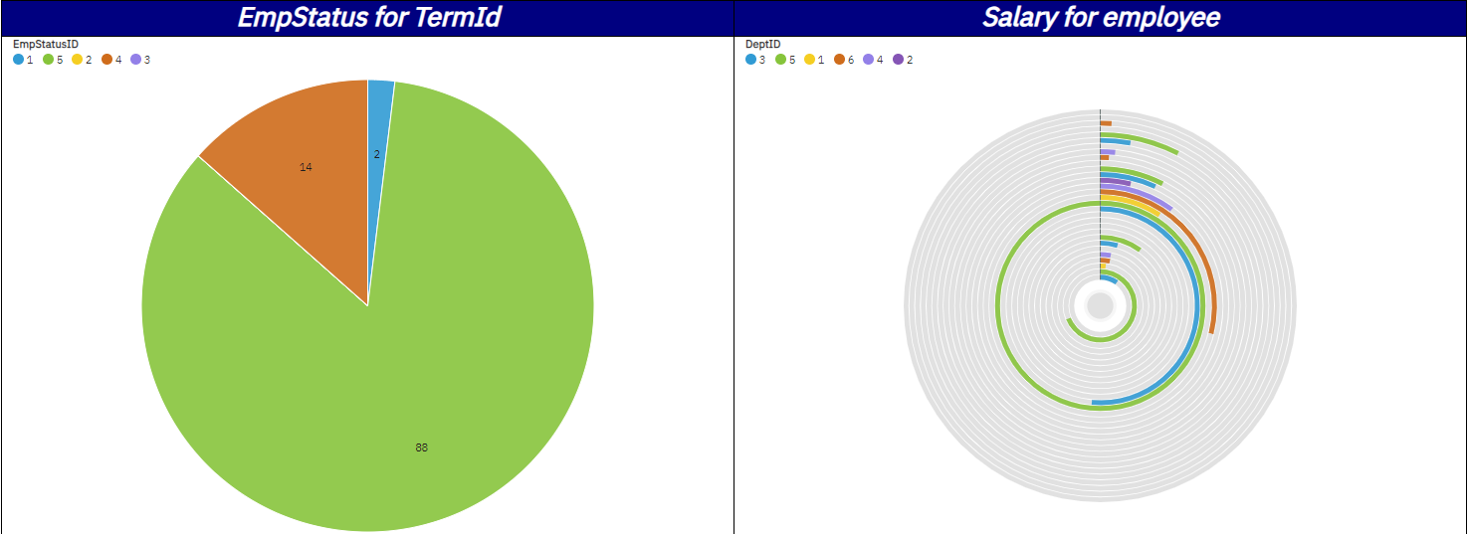

**2. This Dashboard contain all boxed visualizations**

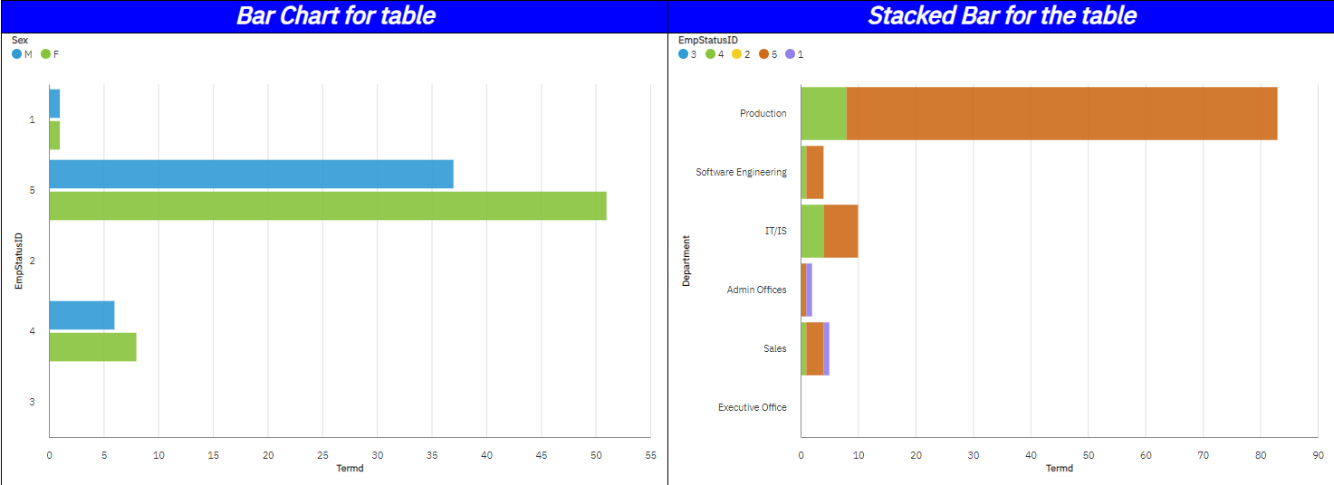

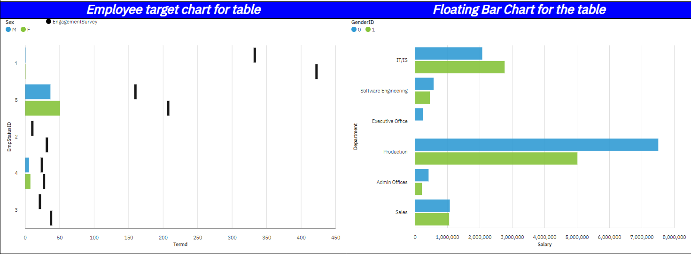

**3. This Report contain no shape just 2**

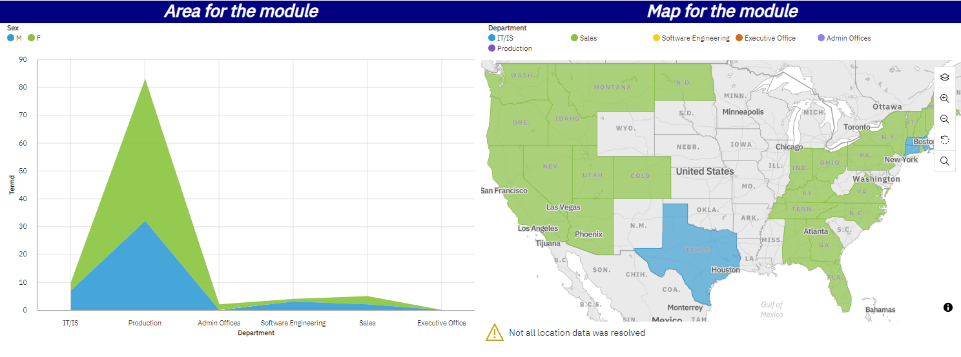

**Now the Stories**

**Story 1**

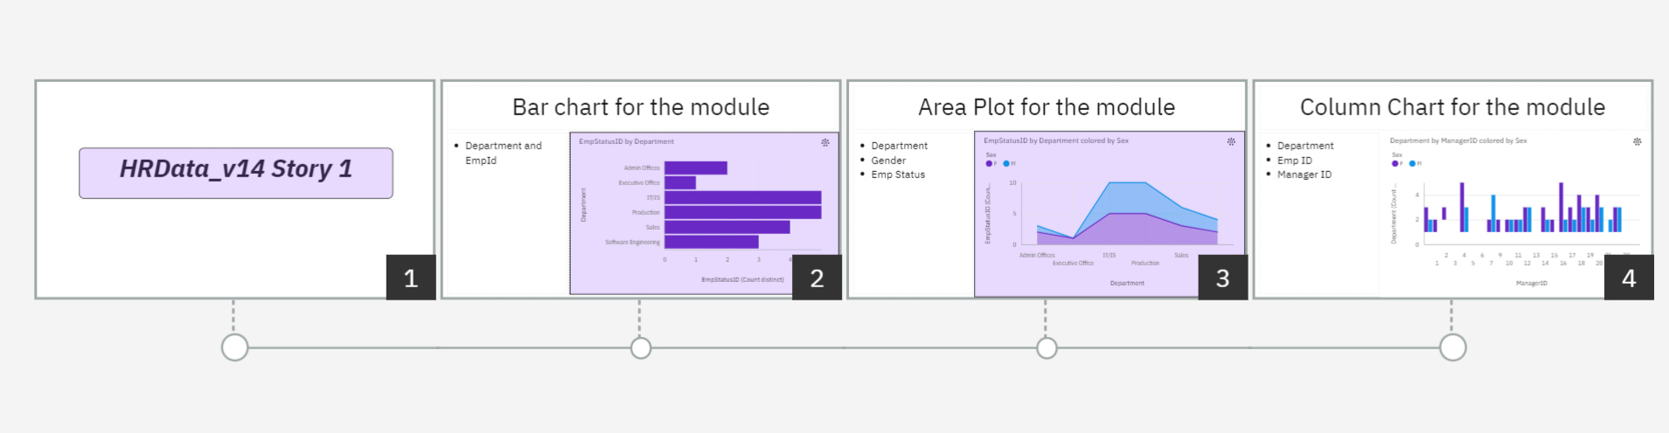

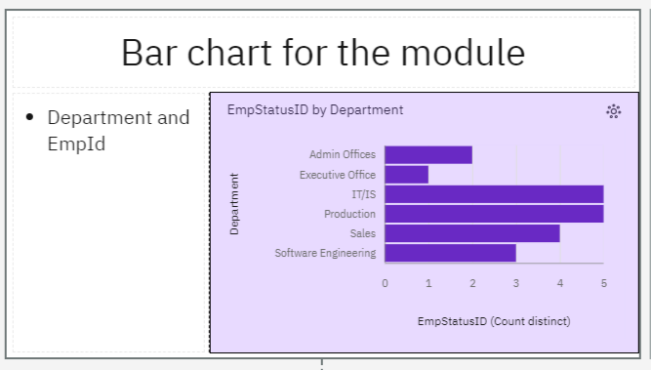

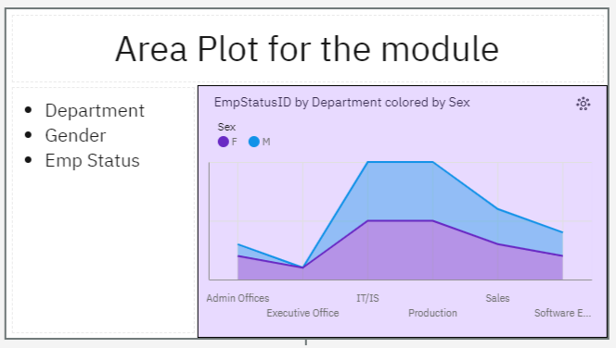

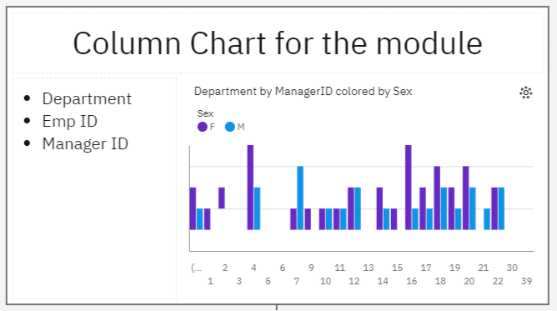

**Story 2**

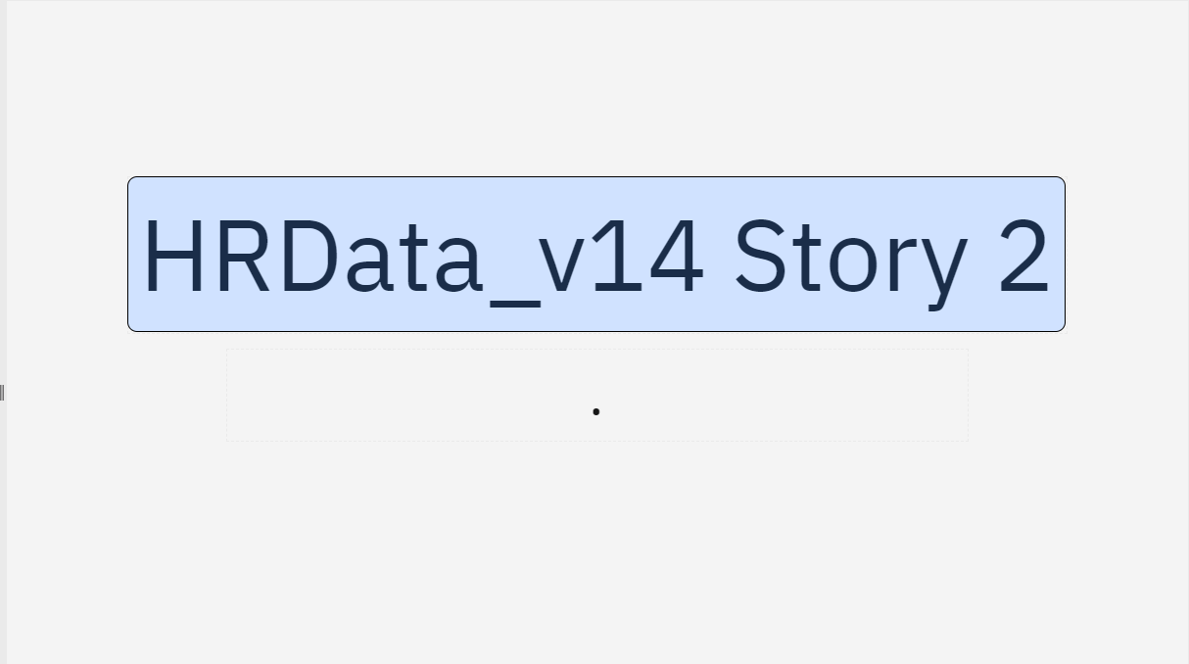

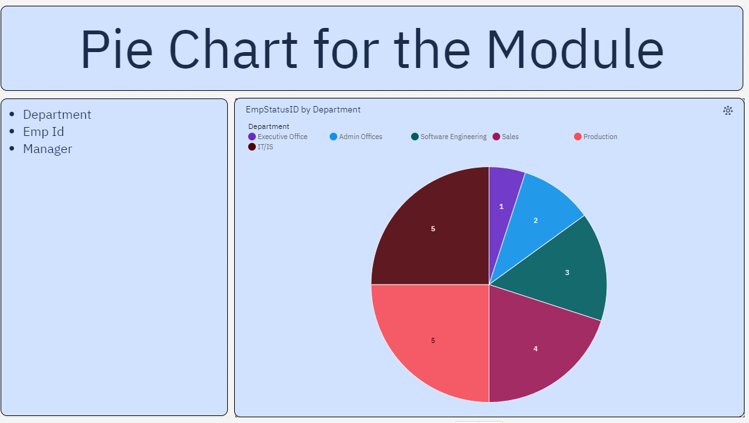

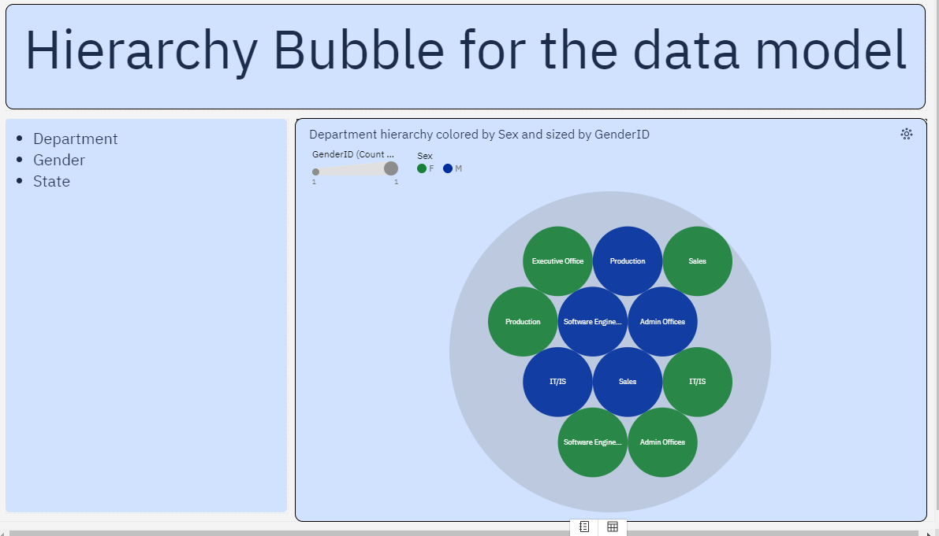

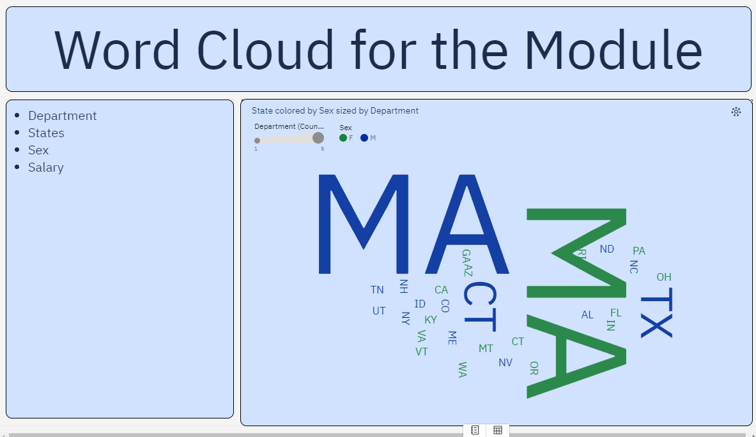

**This is the Assignment 2 of the IBM Data Analytics Course**